**Topics: Normal distribution, Functions of Random Variables**

1. The time required for servicing transmissions is normally distributed with *μ* = 45 minutes and *σ* = 8 minutes. The service manager plans to have work begin on the transmission of a customer’s car 10 minutes after the car is dropped off and the customer is told that the car will be ready within 1 hour from drop-off. What is the probability that the service manager cannot meet his commitment?
2. 0.3875
3. 0.2676
4. 0.5
5. 0.6987

Answer: **0.2676 (B)**

Solution: here, mean *μ* = 45 minutes and *σ* = 8 minutes.

$z-score= \frac{x-μ}{σ}= \frac{x-45}{8}$.

For calculating probability, python is used.

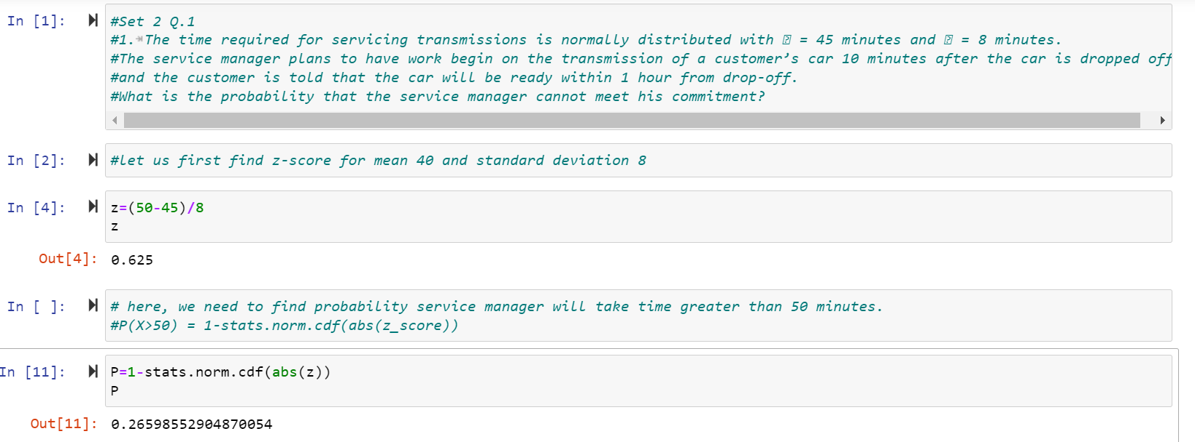

1. The current age (in years) of 400 clerical employees at an insurance claims processing center is normally distributed with mean *μ* = 38 and Standard deviation *σ* =6. For each statement below, please specify True/False. If false, briefly explain why.
2. More employees at the processing center are older than 44 than between 38 and 44.

**FALSE**

As, the probability of employees between 38 and 44 is more as compared to older than 44, so above statement is false.

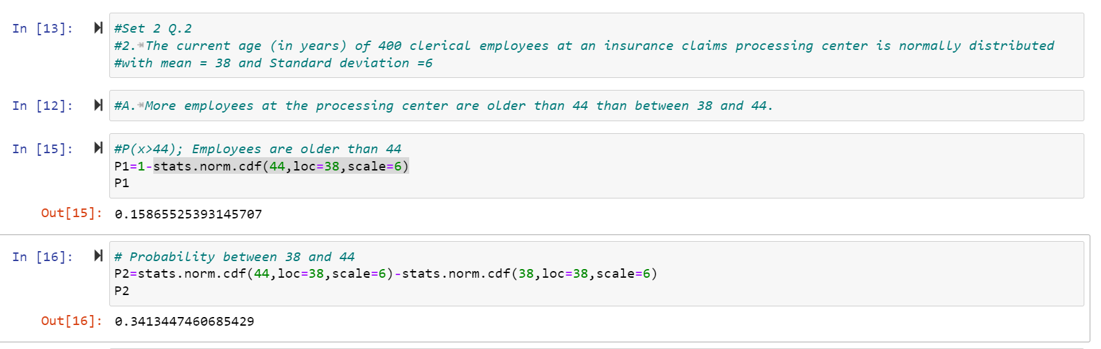

1. A training program for employees under the age of 30 at the center would be expected to attract about 36 employees.

**TRUE**

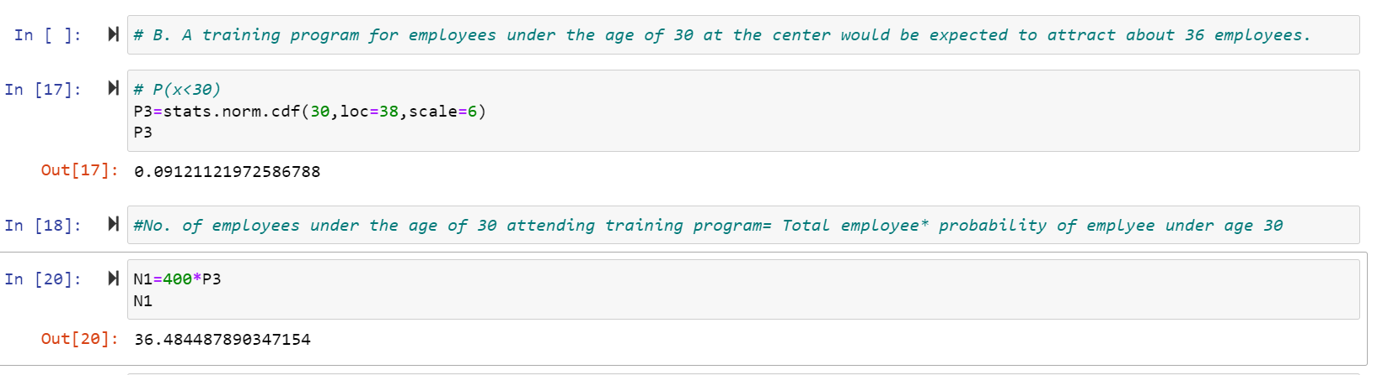

1. If *X1* ~ *N*(μ, σ2) and *X*2 ~ *N*(μ, σ2) are *iid* normal random variables, then what is the difference between 2 *X*1 and *X*1 + *X*2? Discuss both their distributions and parameters.
2. When iid normal random variable is multiply with any constant value>0, its mean is multiplied with constant and variance is N2.σ2.

Accordingly, 2X1~ *N*(2μ, 4σ2)

1. The sum of two independent normally distributed random variables is normal, with its mean being the sum of the two means, and its variance being the sum of the two variances.

Accordingly, *X*1 + *X*2 ~ *N*(2μ, 2σ2)

1. The difference between 2 *X*1 and *X*1 + *X*2 is

2 *X*1 - *X*1 + *X*2 ~ *N*(0, 6σ2)

1. Let X ~ N(100, 202). Find two values, *a* and *b*, symmetric about the mean, such that the probability of the random variable taking a value between them is 0.99.
2. 90.5, 105.9
3. 80.2, 119.8
4. 22, 78
5. 48.5, 151.5
6. 90.1, 109.9

**Answer: D**

We need to find values of a and b such that probability of random variable taking a value between them is 0.99.

So, the probability that a and b have values outside is 1-0.99=0.01.

* The probability towards left from a= 0.01/2=0.05

z-value for probability of 0.05 is -2.5758

Z * σ + μ = X

-2.5758*20+100=48.6

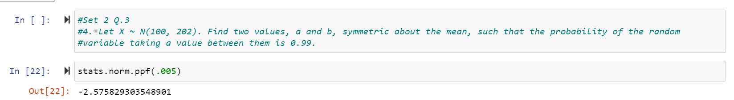

* The probability towards left from a= -0.01/2=-0.005

z-value for probability of -0.005 is 2.5758

Z * σ + μ = X

2.5758*20+100=151.4

1. Consider a company that has two different divisions. The annual profits from the two divisions are independent and have distributions Profit1 ~ N(5, 32) and Profit2 ~ N(7, 42) respectively. Both the profits are in $ Million. Answer the following questions about the total profit of the company in Rupees. Assume that $1 = Rs. 45
2. Specify a Rupee range (centered on the mean) such that it contains 95% probability for the annual profit of the company.

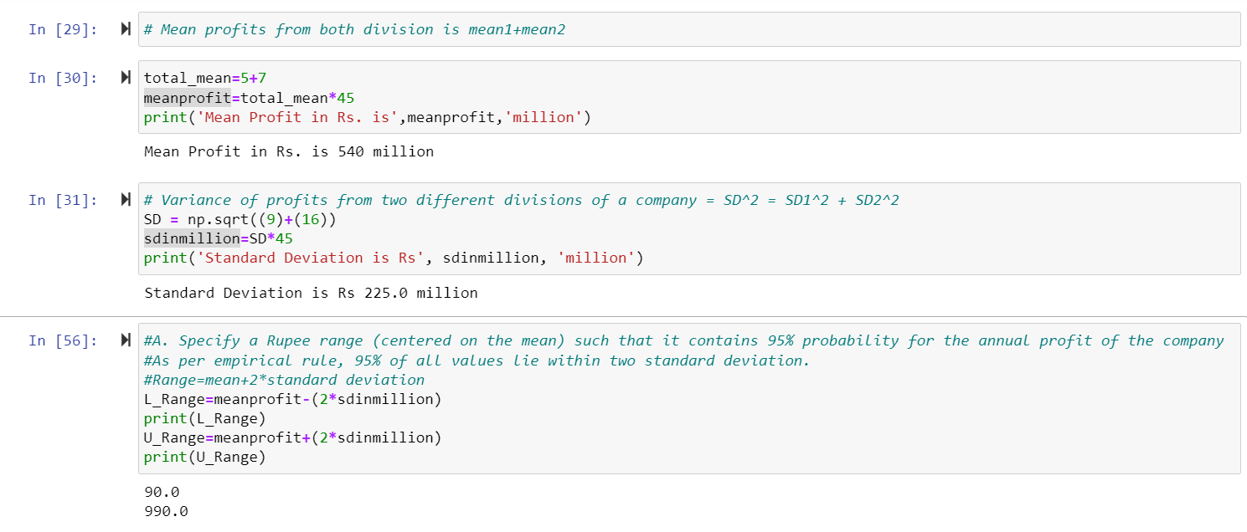

Range is (90.0, 990.0)

1. Specify the 5th percentile of profit (in Rupees) for the company

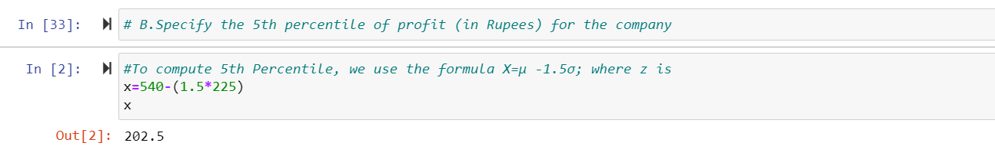

The 5th percentile of profit (in Rupees) for the company is 202.5**.**

1. Which of the two divisions has a larger probability of making a loss in a given year

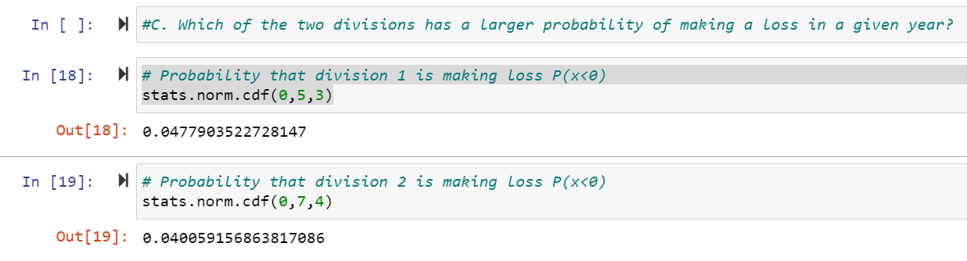

Division 2 is having larger probability of making loss in a year.